**Filipa (plava)**

Haljina - Ted Baker 196,35€ / 1.479,40kn

Torbica - Ted Baker 111,65€ / 841,23kn

Cipele - Nine West 46,41€ / 349,50kn

Sunčane naočale - Saint Laurent, Optika Optotim 225€ / 1.694,25kn

**Ema (crvena)**

Haljina - Patrizia Pepe 199,88€ /1.506kn

Cipele - Aldo 69,68€ /525kn

Torbica - S.Oliver 21,17€ 159,51kn

Sunčane naočale - Chimi, Optika Optotim 101,27€ /763,02kn

**Filipa**

Majica - Lacoste 64,00€ /482,21kn

Minica - Patrizia Pepe 122,50€ /922,98kn

Sandale - Aldo 43,67€ /329,00kn

Torbica - Guess 85,00€ /647,21kn

**Ema**

Haljina - Boss 119,85€ 903,00kn

Sandale - Aldo 64,40€ 485,22kn

Torbica - Patrizia Pepe 122,50€ 922,98kn

**Filipa**

Top - Patrizia Pepe 153,43€ 1156,02kn

Hlače - See by Chloe, XYZ Outlet 193,15€ /1.455,29kn

Cipele - Nine West 43,07€ 324,51kn

Torbica - Patrizia Pepe 191,78€ 1444,97kn

**Ema**

Kosulja - Hugo 104,30€ 785,37kn

Bermude - Boss 139,30€ /1.049,56kn

Cipele - Gai Mattiolo, Corso Roma 105€ /790,65kn

Ogrlica - Patrizia Pepe 114,41€ 862,02kn

Nausnice - Patrizia Pepe 60,52€ 455,99kn

Narukvica - Patrizia Pepe 99,01€ 745,54kn

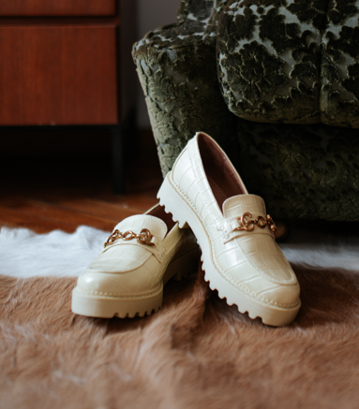

Zute mokasine - Nine West 54,07€ /407,39kn

Ruksak - Guess 99,90€ /752,70kn

Pletena okrugla torbica - Ted Baker 177,10€ /1.334,36 kn

Roze metalik sandale Aldo 51,80€ /390,29kn

Roze sunčane naočale Chimi, Optika Optotim 115,73€ /872,00kn